Introduction To Programming Languages

A script is a sequence of instructions written in a proper language through which the computer can understand and solve the problem given to it. It is the method by which the whole computing process is directed and controlled. Preparing a script for the computer is known as **“programming”.**

A script should be recorded on a proper medium which the computer can process. Usually punched cards are used for this purpose. Each computer can understand one language which is known as **“machine language”.**

Machine language contains use of numeral codes and each computer has its own machine language. It is very difficult to write a programme in this language. To obliterate this difficulty, some other languages have been developed.

A machine oriented language is oriented to a particular computer and not oriented to a particular problem. To avoid this difficulty, problem oriented languages have been developed. It is easier to write programmes in these languages. These are also known as high level languages.

Python

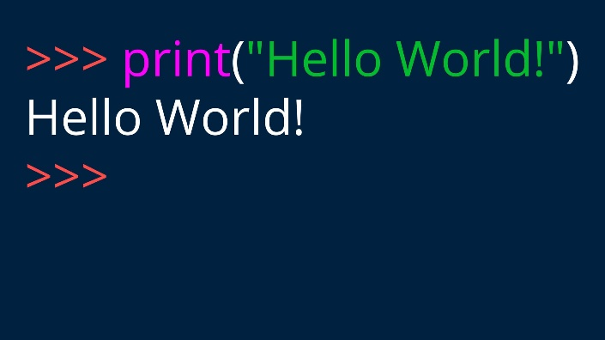Python is an interpreted, object-oriented, high-level programming language with dynamic semantics. Its high-level built in data structures, combined with dynamic typing and dynamic binding, make it very attractive for Rapid Application Development, as well as for use as a scripting or glue language to connect existing components together. Python's simple, easy to learn syntax emphasizes readability and therefore reduces the cost of program maintenance.

Often, programmers fall in love with Python because of the increased productivity it provides. It is often described as a "batteries included" language due to its comprehensive [standard library](https://en.wikipedia.org/wiki/Standard_library).

Python consistently ranks as one of the most popular programming languages.

Java

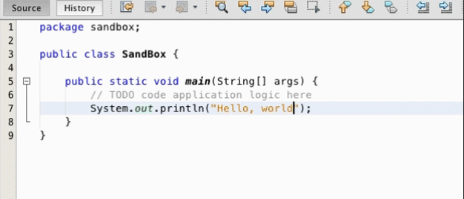**Java** is a [high-level](https://en.wikipedia.org/wiki/High-level_programming_language), [class-based](https://en.wikipedia.org/wiki/Class-based_programming), [object-oriented](https://en.wikipedia.org/wiki/Object-oriented_programming) [programming language](https://en.wikipedia.org/wiki/Programming_language) that is designed to have as few implementation [dependencies](https://en.wikipedia.org/wiki/Dependency_(computer_science)) as possible. It is a [general-purpose](https://en.wikipedia.org/wiki/General-purpose_language) programming language intended to let [programmers](https://en.wikipedia.org/wiki/Programmer) *write once, run anywhere* ([WORA](https://en.wikipedia.org/wiki/Write_once,_run_anywhere)), meaning that [compiled](https://en.wikipedia.org/wiki/Compiler) Java code can run on all platforms that support Java without the need to recompile.. The syntax of Java is largely influenced by [C++](https://en.wikipedia.org/wiki/C%2B%2B) and [C](https://en.wikipedia.org/wiki/C_(programming_language)). , while having fewer [low-level](https://en.wikipedia.org/wiki/Low-level_programming_language" \o "Low-level programming language) facilities than either of them.

C++

**C++** is a [general-purpose programming language](https://en.wikipedia.org/wiki/General-purpose_programming_language) created by Danish computer scientist [Bjarne Stroustrup](https://en.wikipedia.org/wiki/Bjarne_Stroustrup" \o "Bjarne Stroustrup) as an extension of the [C programming language](https://en.wikipedia.org/wiki/C_(programming_language)), or "C with [Classes](https://en.wikipedia.org/wiki/Class_(programming)" \o "Class (programming))".

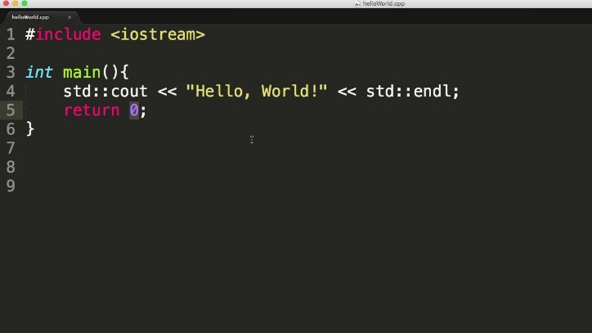C++ was designed with an orientation toward [systems programming](https://en.wikipedia.org/wiki/Systems_programming" \o "Systems programming) and [embedded](https://en.wikipedia.org/wiki/Embedded_software" \o "Embedded software), resource-constrained software and large systems, with [performance](https://en.wikipedia.org/wiki/Performance_(software)), efficiency, and flexibility of use as its design highlights. C++ has also been found useful in many other contexts, with key strengths being software infrastructure and resource-constrained applications,[]](https://en.wikipedia.org/wiki/C%2B%2B#cite_note-Stroustrup1-11) including [desktop applications](https://en.wikipedia.org/wiki/Application_software), [video games](https://en.wikipedia.org/wiki/Video_game_development), [servers](https://en.wikipedia.org/wiki/Server_(computing)" \o "Server (computing)) (e.g. [e-commerce](https://en.wikipedia.org/wiki/E-commerce), [web search](https://en.wikipedia.org/wiki/Web_search_engine), or [databases](https://en.wikipedia.org/wiki/Database" \o "Database)), and performance-critical applications (e.g. [telephone switches](https://en.wikipedia.org/wiki/Telephone_switches" \o "Telephone switches) or [space probes](https://en.wikipedia.org/wiki/Space_probes" \o "Space probes)).

HTML

HTML, or Hypertext Markup Language, is the programming language used to build the internet. It is the standard language for web programming, along with CSS and JavaScript.

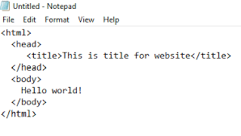[Web browsers](https://en.wikipedia.org/wiki/Web_browser) receive HTML documents from a [web server](https://en.wikipedia.org/wiki/Web_server) or from local storage and [render](https://en.wikipedia.org/wiki/Browser_engine) the documents into multimedia web pages. HTML describes the structure of a [web page](https://en.wikipedia.org/wiki/Web_page) [semantically](https://en.wikipedia.org/wiki/Semantic_Web) and originally included cues for the appearance of the document.

[HTML elements](https://en.wikipedia.org/wiki/HTML_element) are the building blocks of HTML pages. With HTML constructs, [images](https://en.wikipedia.org/wiki/HTML_element#Images_and_objects) and other objects such as [interactive forms](https://en.wikipedia.org/wiki/Fieldset) may be embedded into the rendered page. HTML provides a means to create [structured documents](https://en.wikipedia.org/wiki/Structured_document) by denoting structural [semantics](https://en.wikipedia.org/wiki/Semantics) for text such as headings, paragraphs, lists, [links](https://en.wikipedia.org/wiki/Hyperlink), quotes and other items. HTML elements are delineated by *tags*